Chapter One Study Guide
Canadian Provinces, Territories and Capital Cities
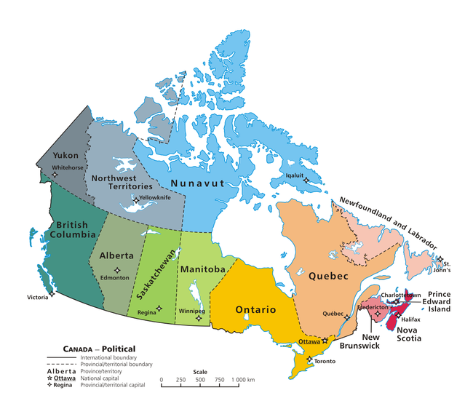
Name the six regions of Canada
-Arctic Region
- Cordillera Region
-Interior Plains Region
-Canadian Shield Region
-Great Lakes Region
-Atlantic Region
Who was Rick Hanson: A man who wheeled across Canada to raise money and awareness for people with spinal cord injuries.
A region shares the same climate, weather, lines of latitude, landforms, bodies of water and elevation.
Canada’s Natural Resources: Air, water, soil, fish, birds, mammals, trees, wildflowers, grasses, metals, non-metals, fuels, metals, non-metals.
People feel very connected to the region they live in.
A persons clothing, transportation, recreation housing and jobs are all determined by the region they live in.
First Nations, Inuit people have always been living in Canada.
Metis people were of First Nations and European descendants
The Vikings were the first Europeans to arrive in Canada.
The French and British set up colonies in Canada. They were the first Europeans to settle in Canada after the Vikings.

Words Matter
Climate : The kind of weather an area has over a long period of time.
Weather: Daily temperature, for example rain, sunshine, or snow.
Renewable natural resources: the natural resource can be replaced. For example, trees, solar energy, wind and water.
Non-renewable natural resources- resources that cannot be replaced once it is used up. For example, coal, oil and animal by products.
Industries are businesses that produce goods or services.
Heritage: is what has been passed down to you.
Ancestors: are the people in your family who have come before you.
Diverse: means made up of people from a variety of cultures and backgrounds.

