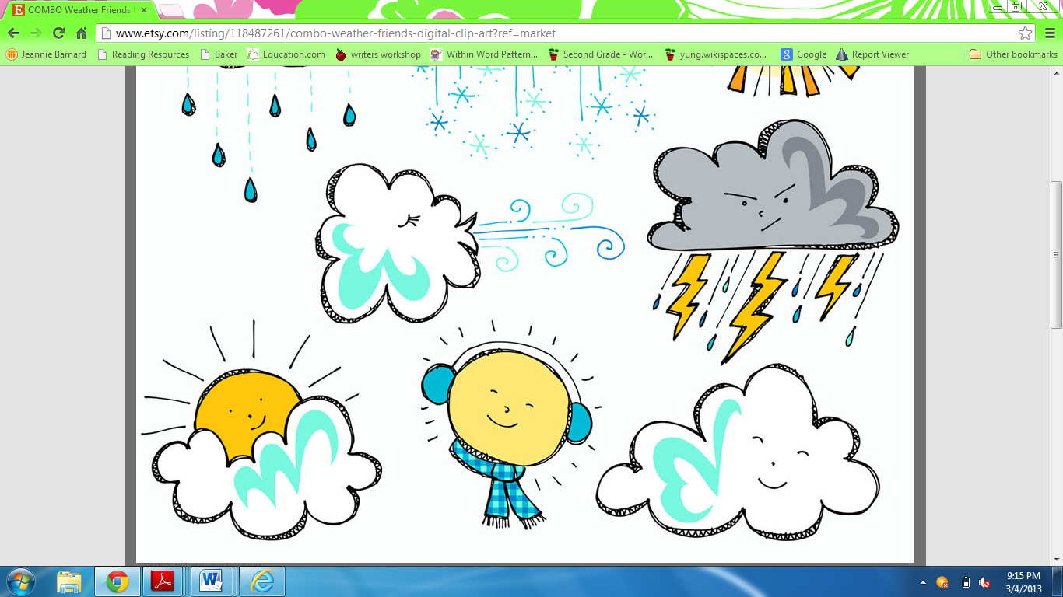Name: ________________

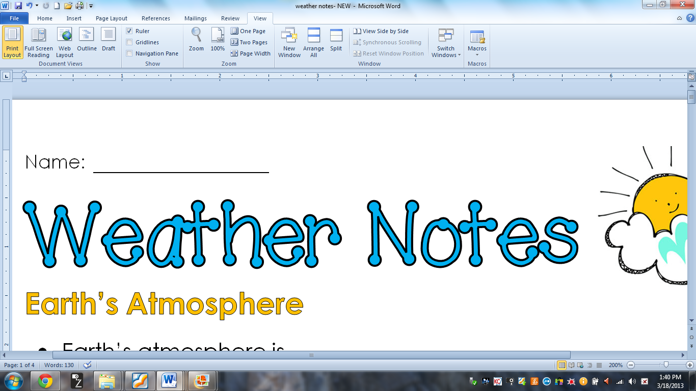**W**

**Earth’s Atmosphere**

* Earth’s atmosphere is: A blanket of air that surrounds and protects the earth.
* **The Layers of the Atmosphere**:

1. Troposphere: The layer we live in, and where weather occurs.

2. Stratosphere: The layer that protects the Earth from harmful UV rays, and where the ozone layer is located.

3. Mesosphere: The layer that protects the Earth from meteors.

4. Thermosphere: The layer where satellites are located.

**Weather & Climate**

* Weather: What the air around us is like at certain period in time.
* Example: Rain, snow, sleet, hail, sunshine
* Climate: The pattern of weather in a certain place over a long period of time.

**Properties of Air**

1. Air takes up space, and takes the shape of its container.
2. Air has layers (the layers of the atmosphere)
3. Air pushes on things and has pressure.
4. The temperature of air can be measured.

**Air Masses & Fronts**

* Air mass: A large body of air with the same temperature and moisture.
* Front: When a two air masses meet, and a weather change occurs.

1. Warm Front:

- When a warm air mass stretches over a cold air mass.

- Light steady rain or snow occurs for longer periods of time.

2. Cold Front:

- When a cold air mass pushes up and under a warm air mass

- Heavy rain, thunderstorms, or snow occur for short periods of time.

 Cold Front Symbol Warm Front Symbol



**Tools for Measuring Weather**

* Meteorologists use weather tools to: measure and predict the weather to prepare citizens.
* Anemometer: Measures the speed of the wind.
* Hygrometer: Measures the amount of humidity in the air.
* *Humidity*: The amount of water vapor in the air.
* Rain Gauge: Measures the amount of rain that has fallen.
* Thermometer: Measures the temperature of the air.
* Barometer: Measures air pressure.
* Weather Vane: Measures the direction the wind is blowing.

**Types of Severe Weather**

* Tornado: A rotating column of air that touches both the clouds in the air and the ground.
* Hurricane: A strong tropical storm with dangerous winds and heavy rain.
* Blizzard: A dangerous winter storm with hazardous winds and heavy snow.
* Flooding: When water levels rise to an unsafe level because of heavy rain or melting snow.

* Thunderstorm: A dangerous storm with lightning and thunder.